Project Update - April 2020
1. THE PROPOSED NEW HANGAR AND WORKSHOP
The restoration of the Museum’s Spitfire has now reached a critical point. To proceed with the restoration, the Spitfire now has to be placed into jigs. The present workshop area is far too small so we need a larger secure area. As the South African Air Force (SAAF) occupy all the present suitable facilities on the base, the South African Air Force Museum (SAAFM) has approved and allocated an area to the Project for such a new facility to be constructed. This will then have a long term role as the restoration hangar for the Museum.

2. FUNDRAISING FOR RESTORATION HANGAR
We are now fund raising for the restoration hangar. We have invited three companies to quote for the supply and erection of this new hangar. Once completed, relevant components of the airframe will be moved to this facility, in order of priority, as and when ready to be restored.

3. THE PERFORMANCE CENTRE FORD MUSTANG PROJECT
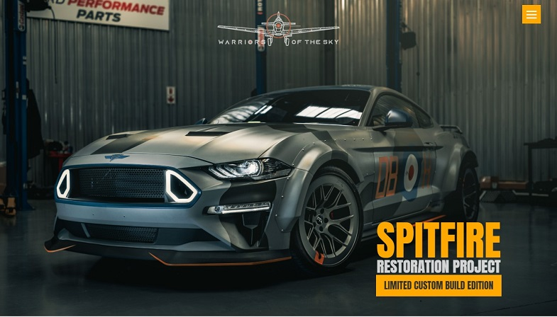
The Spitfire Project was approached by the Ford Mustang Performance Centre, wishing to support the Project. They offered to build ten themed supercharged 5 litre V8 Ford Mustangs, each uniquely painted in a specific South African “Ace” colour scheme. The theme of each will be different, with the first in the colours 5518, as it will be when it is restored. These will be the colours she wore in 1950, as DB-H. The remaining nine Ford Mustangs will represent the colours of various aces and flying legends of the Spitfire era. For each Ford Mustang sold, Performance Centre will donate a significant amount to the Spitfire Restoration Project. Their project is called Warriors of the Sky, so, please visit them at www.warriorsofthesky.co.za for more information on the cars. Should you be interested in purchasing one, please contact them, or any of the Spitfire SteerCo members.

4. RESTORATION OF THE SPITFIRE CANOPY AND WINDSCREEN SECTIONS
Col. Tony Smit has been extremely busy, as usual. Tony has had the Spitfire canopy fully restored and polished. He transported the windscreen section to Jan Diener at AcrylForm in Cape Town, where the repair took place and then back to Pretoria, to Johan Lok at Warbirds who assembled and completed the work. This was all done at his own expense.
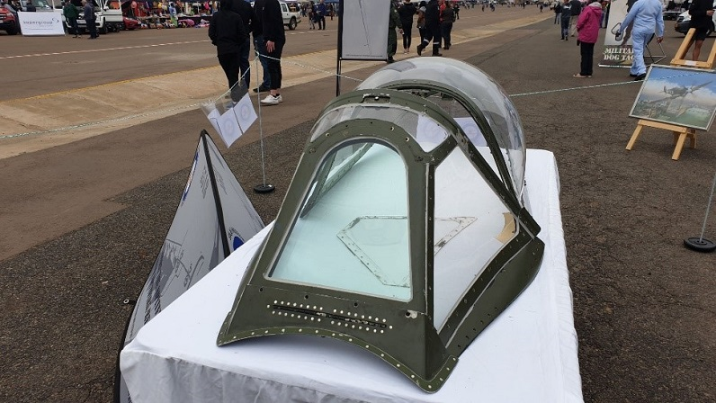

5. MODEL AIRCRAFT KITS
A very close friend of Mario Vergottini, one of Tony Smit’s associates and a keen modeller, donated his collection of unbuilt models to the project when he departed this world. His family ensured that the project received this significant collection. Further donations have since been made. Together there were over five hundred models. Dave Evans has been selling these and has so far raised in excess of R50 000: a significant contribution to the Project funds. The remaining models are on sale in hangar 3 at the Museum at AFB Swartkop on the Training Days: the morning of the first Saturday of each month – once the Covid-19 lockdown ends.
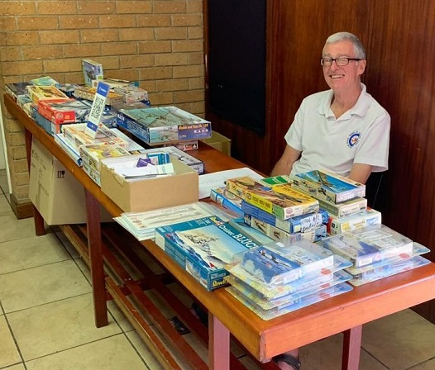

6. DONATION OF 5/8 SCALE SPITFIRE
Once again, Tony has been contacting friends and colleagues. A further friend, who is no longer with us, had a 5/8 scale Spitfire. This aircraft has no engine or propeller. Tony approached the family and this aircraft has been donated to the Project.

7. DONATION OF THREE PAINTINGS BY BAZIL KRIEL
Bazil has again made a significant donation to the Project, in the form of two framed versions of Tony Butler’s picture of Spitfire in the Clouds. Bazil himself added a third framed print as well.
The aim of collecting all these art works is to offer them for sale at an auction and gala dinner. The funds raised will then be used for the Spitfire Restoration Project.

8. GRAHAM MacDONALD DONATION OF SPITFIRE PARTS
Graham MacDonald, a businessman from Kloof in Kwazulu Natal, was involved in various aircraft restorations. One such restoration in which Graham was involved, was that of a Tiger Moth and a Spitfire. Sadly, that Spitfire departed South Africa before it was completed. Graham had various Spitfire instrumentation and fuselage frame 19, which he generously donated to the Spitfire Restoration Project. Our deep gratitude to Graham.

9. DONATION: PAINTING BY BEN JONKER
Ben Jonker has generously offered a framed printed version of his painting of AX-K to the project. Ben added a collection of prints of this painting, signed by Lt Col Dave Knoesen, retired Officer Commanding of the Museum and Spitfire display pilot.
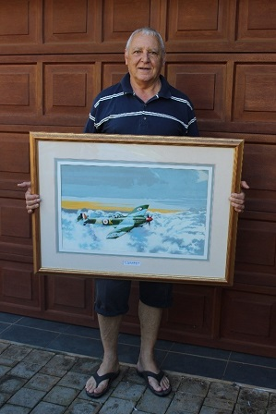

10. DONATION: SPITFIRE RADIO HEADSET
Albert Robinson had an authentic Spitfire Radio Headset, which he has generously donated to the Project.
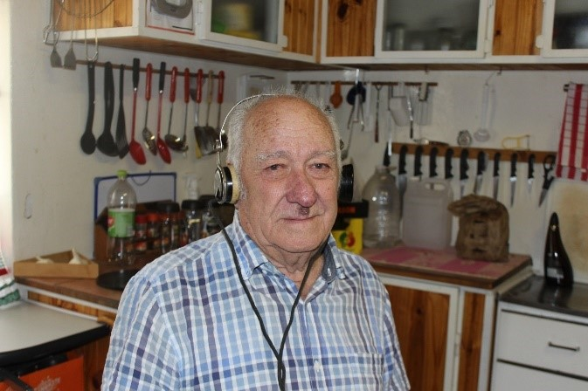

11. DONATION: BRAKE PRESSSURE GAUGE
Recently, on our Facebook Page, a genuine Spitfire Brake Pressure Gauge was offered. Warwick Cook very kindly purchased the Gauge and presented it to the Project.
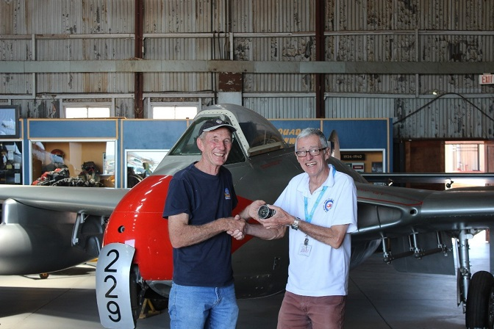

12. AL WENGER DONATION
A good friend of Tony Smit, Al Wenger donated US$8 000 to the Restoration Project. To date, this is the largest single donation. We are hugely appreciative of Al’s generous donation.

13. JAMES FEUILHERALDE DONATION
James Feuilherade, an ex-SAAF pilot, who served with Col Tony Smit and later served at the Museum, flying the Spitfire, donated AUS$300 to the Restoration Project. We are very grateful to James for his generous donation and support to the Restoration Project.

To all who have contributed to the Project, we offer our sincere gratitude.
To our team members and supporters, it is with your energy and support that we are now where we are.
Should anyone wish to become involved in any way or means, please contact Ian Grace, project lead, on +27 82 452 5291 or iang@xsinet.co.za.

