Project Update - May 2017
Thanks to the Department of Home Affairs, I have recently been in the UK for 9 weeks, obtaining a resident’s visa during this extended stay (I missed the Swartkop Air Show) but was able to visit many of the top Aircraft Museums and do some research. Whilst I was in the UK, progress continued on the project, thanks to our dedicated volunteers: the continued stripping of the fuselage is now complete. The primary focus however was on preparations for the Air Show and the Spitfire Pilots Re-union of which I am sure you have seen the press releases and updates.
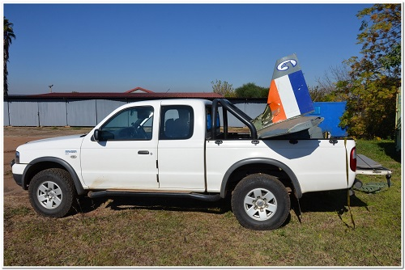
Photo Above: Bakkie with new empennage: take off in 15 minutes?
We have also been pushing forward with the sub-project of simulators and have made some great progress, including a possible offer of a professional level simulator for the Museum.
Projects with AeroSud and local colleges have also gained momentum. Recent actions have seen the tail-plane and pilot’s seat placed in the workshop, in order to carry out inspection and repair assessments.
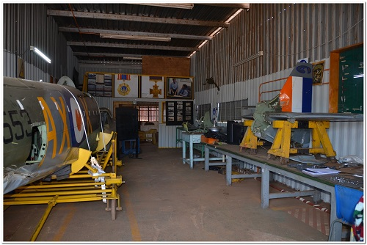
Photo Above: Empennage transferred to the workshop
There are some brief notes on my visits whilst in UK below, with a final more in depth report with more pictures to follow:

RAF Duxford
This visit was pre-arranged with the help of Graham Hutchinson, our man on the ground there. I got to visit not only the Imperial War Museum but also the more important (to us) repair facilities there. Key items were viewing fuselage, wing and engine mounting jigs and how they were used. These facilities also make and stock a large number of Spitfire spares for sale. The day was made, however, by the test flying of a Spitfire straight off the repair line; this entertained us for a couple of very pleasant hours.
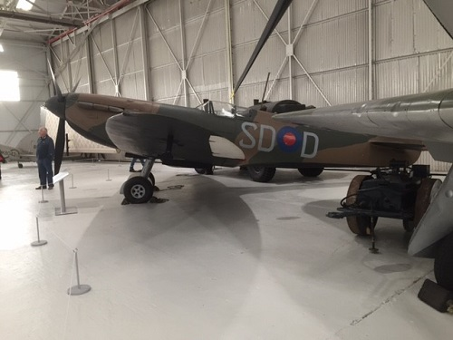
Photo Above: Keith Pratt, and what's that aeroplane, again?
RAF Cosford
This is the sister Museum to RAF Hendon, which I visited last year, but as we discovered, it houses the main restoration centre for the RAF: the “Michael Beetham Conservation Centre.” We were made most welcome wherever we went on site and have made contact there with the Restoration Manager, who is keen to set up permanent links. We viewed a Mk 1 Spitfire and also the infamous 1 to 1 scale Airfix Model Spitfire constructed by James May of TV fame. Entry here is free, and the highlights were the simulators and the virtual reality centre, which is chargeable, but which keeps children and adults entertained for hours.
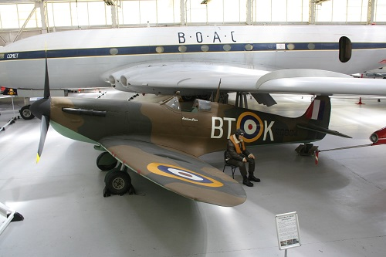
Photo Above: James May's (in)Famous 1:1 scale Airfix Spitfire
Biggin Hill Heritage Hanger
13 Spitfires are housed here both for repair and entertainment. Many Merlin engines line the workshop walls and many other spares are available. We discussed in detail how we could do business together and the best way to progress with our project. Visits here are by conducted tours, cockpit visits, and indeed flights in two seat Spitfires. (A flight of 30min is £2,550: well over R40 000 !) I was shown 2 ex SAAF Spitfires and offered the opportunity to buy one at £2.8 million – over R46 million. I was regrettably unable to oblige. Sadly my camera failed to download on the day but Biggin Hill have agreed to forward photos to me.
Biggin Hill Heritage Hanger
This was not my first visit here, but I wanted to carry out further research on both the Spitfire simulator and the wonderful contribution made by SA men and women to this organisation during WW2. These pilots delivered all types of aircraft from the factory to the front line before the radios were fitted. Map reading was clearly a necessary skill and difficult in the UK’s cloudy skies. One such pilot was a local from Pretoria who used to ride her bike to Swartkop to watch the planes as a child in 1938. She became the first SA woman to do a parachute jump, at age 17 at Swartkop. Then off to WW2 to fly ! Jackie Moggeridge (Sorour) has written a book: Spitfire Girl.
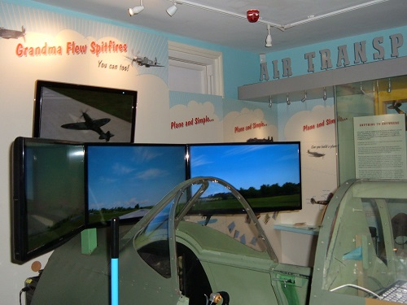
Photo Above: Example of a Spitfire simulator at the Air Transport Auxiliary
These visits have achieved:
Active personal contacts at each stop;
Active opportunities for website links;
An appreciation of the supply system, of spares, supply & purchase;
An understanding of the strategy used by these organisations; and
I got to see a Spitfire or two!
Keith Pratt, May 2017.

