Project Update - October 2017
Some inspirational thoughts for our project team, and supporters:
• "When everything seems to be going against you remember that the airplane takes off against the wind, not with it" - Henry Ford
• "The most difficult thing is the decision to act, the rest is merely tenacity" - Amelia Earhart
• "A person who never made a mistake never tried anything new" - Albert Einstein
• "Believe you can and you are halfway there" - Theodore Roosevelt
"Light at the end of the tunnel"
Why you may ask? Progress on all fronts as you will see below.

PR & Social Media
The project’s social media, Facebook and webpage have been buzzing with activity across the world, with new business contacts active on our behalf in UK, Canada, New Zealand and Australia. We have increased our Facebook followers/likes significantly in the last few months (1150 plus likes). If you are on Facebook please like our page for updates on the project and share with your friends and family. We are also now on LinkedIn, Twitter (@spitfire5518) and Instagram (@spitfirerestoration). This is mainly due to the wonderful work of Karen and Keegan.

Simulators
Our plans are taking shape to build and operate a school of simulators ranging from baby carts to serious pilot trainers in order to raise money for the project. The thought is that we should become the “Warbird Pilot Training Centre” for Southern Africa. Progress has taken place in the following areas.
A visit was arranged to “SIMUFLIGHT” in July. The CEO and Owner, Mr Alfredo Schultz, gave us an interesting briefing over coffee, on what they do and the differences between the various types of simulators. The team was then given a tour of the factory workshop where four aircraft and one helicopter simulator being built were in various stages of completion. Tony Smit, our flight expert (and visit organiser) demonstrated the Beechcraft B1900 Simulator. Vincent, Ian & Don from the committee were given the opportunity to fly the simulator and all were most impressed. Tony is now arranging further interviews and visits to take this element of the visit forward.
Negotiations continue with Cape Town Museum for the loan of two further simulators, being a Messerschmitt Bf 109 and Hawker Hurricane.
Discussions also include the building of a Spitfire Simulator at Swartkop. There will be much more to say on this subject in due course: hopefully it won’t be to long until you all (no matter what age) can fly our simulators at Swartkop.

Admin (Because someone has to do it....)
The recent Museum Council Meeting made some very important decisions which have very positive implications to the project:
Thanks go to John Bayne and Dave Evans for achieving the following:
- The building of our new Workshop facility has been approved, subject now only to ground survey reports and a design that accommodates the degree of risk because of the dolomitic conditions. Detailed planning is already underway.
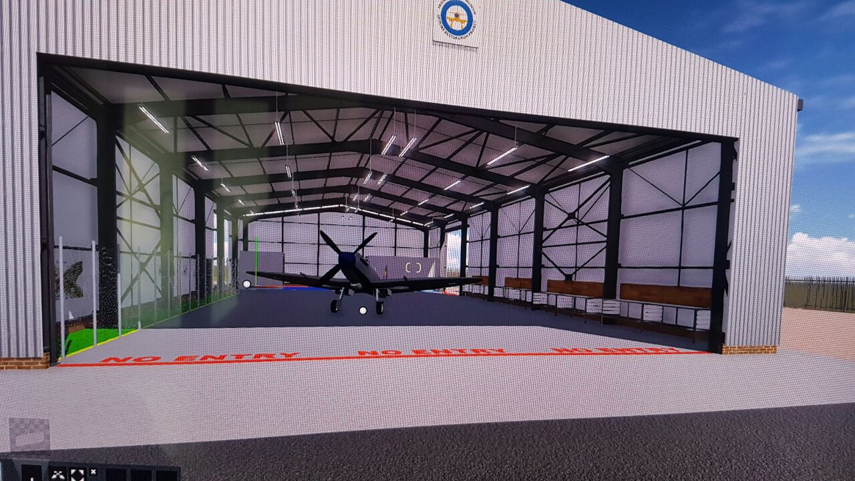 | 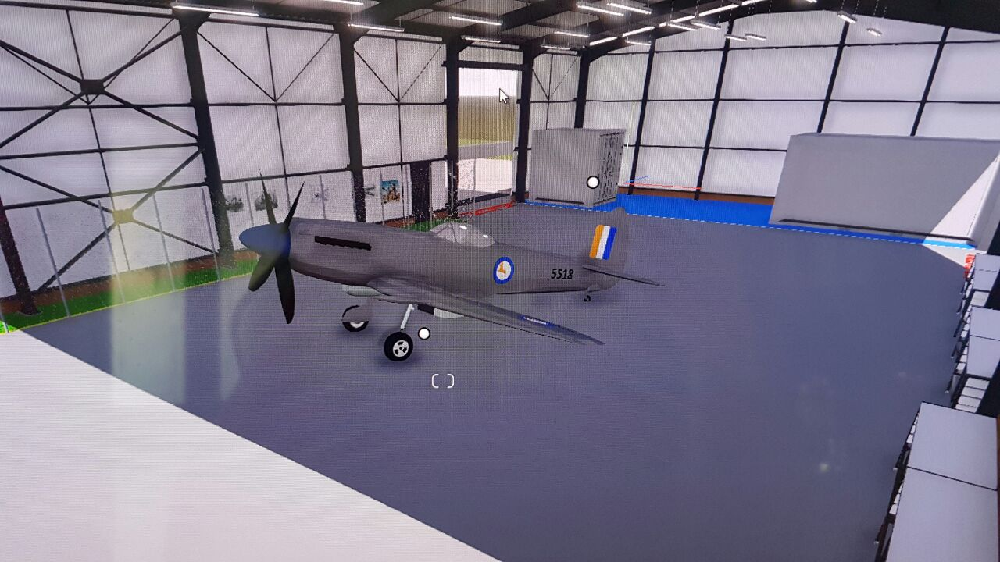 | 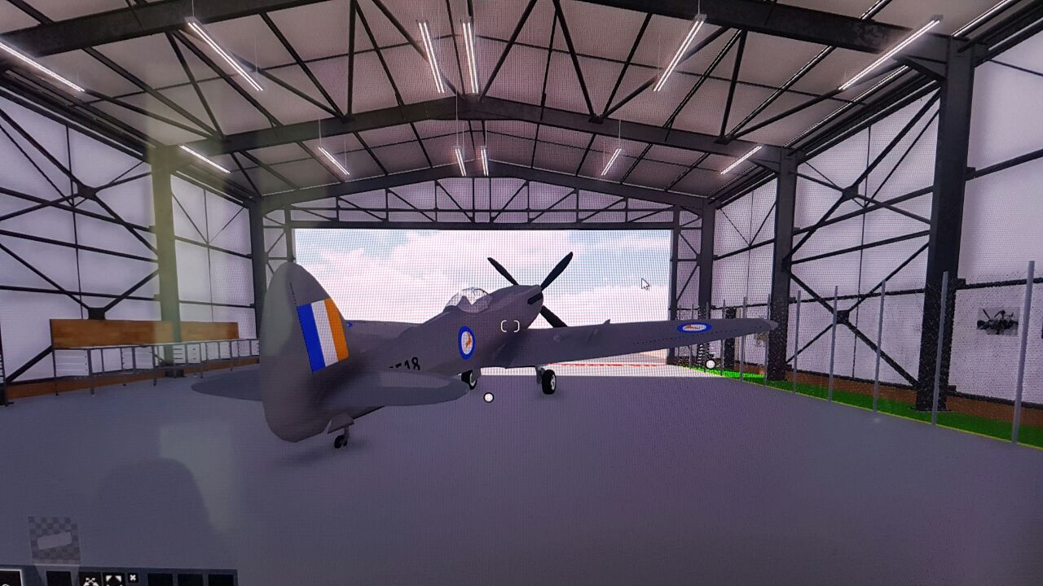
- Permission has been granted for regular access to the two Merlin Engines (both involved in 5518 accidents) and stored at Swartkop. These will now become part of the overall registration process, each part being examined and recorded for repair or replacement decisions to be made.
- We are also currently investigating sponsorship offers which will hopefully include the empennage being repaired by sponsors.

Shop
Vincent continues to work wonders in the shop aided by his family, Karen and others. You may have noticed the new Pink Caps on sale (for the ladies, I hope.) New products coming soon will include Spitfire table mats and coasters, a must for your Xmas shopping.
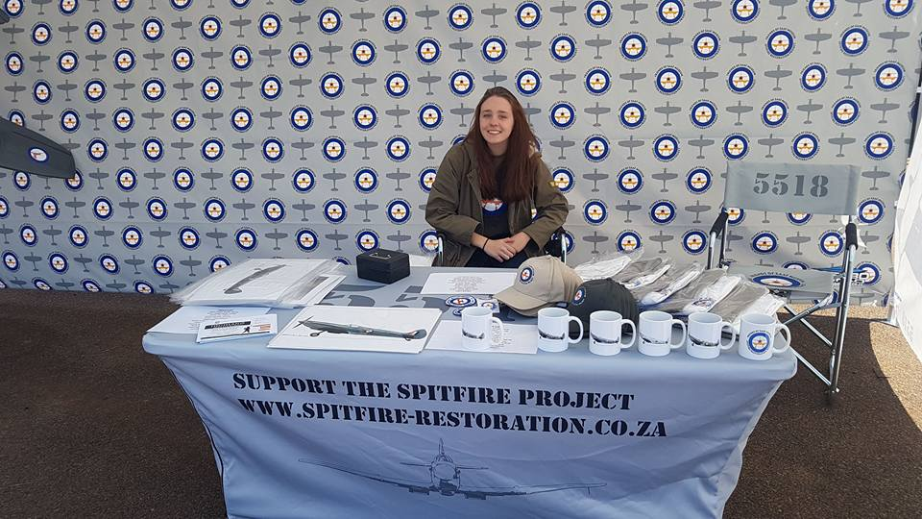 | 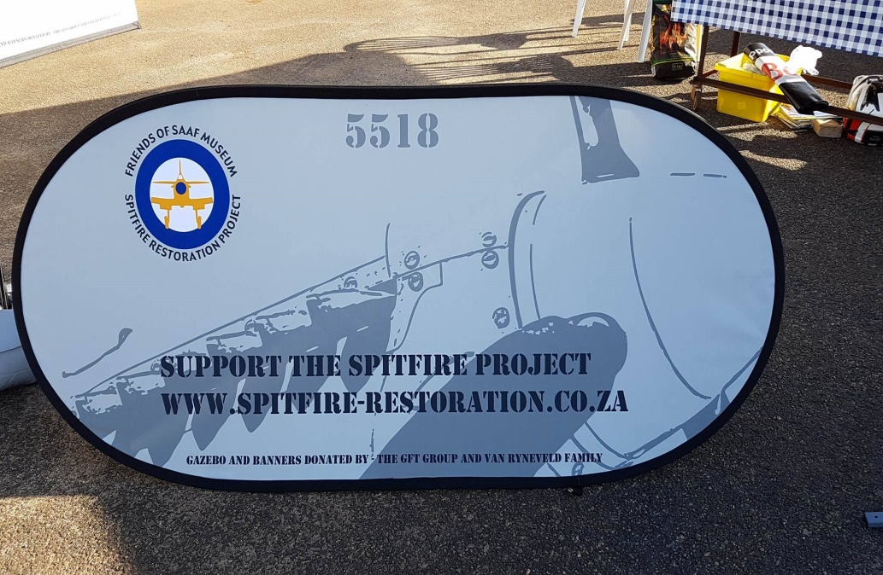 | 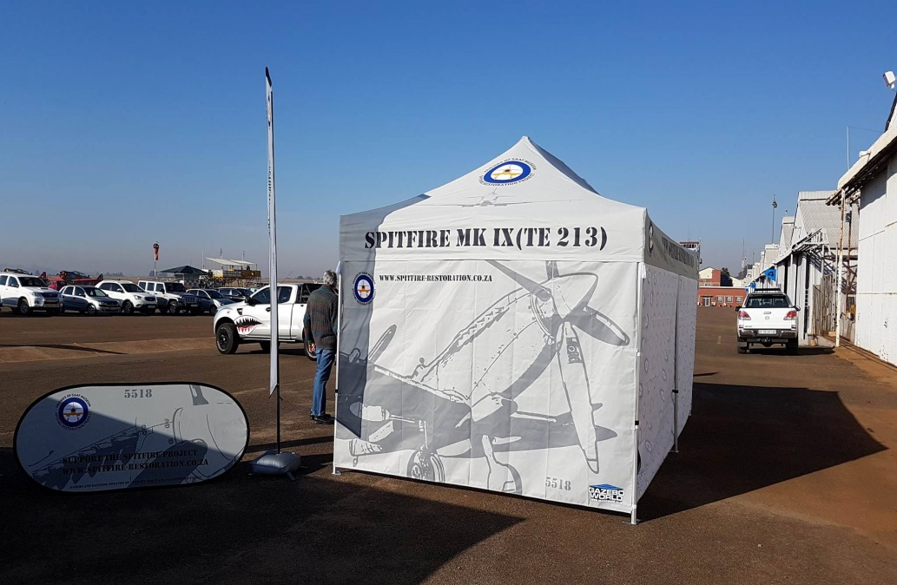

Youth Of Today
Over recent months we have very gladly had an influx of much younger volunteers these include Linton Ritchie, Ben Pietersen, Mathew Olivier, Montague Thorne, David Macedo who are currently making regular contributions to our cause and probably lowering the average age by half. This adds to the skills group of volunteers in that there is much more awareness of modern developments which when added to the traditional skills of the older guys creates a better balance.
Some of the members were asked recently to supervise a group of university students on work experience at the base which was quite an experience. Great bunch of youngsters and the aged instructors were entertained/given lessons by continuous RAP Music. Thanks Louis, Theo, Phil, Mike. /p>
Wanted
Spitfire Spares: We have recently discovered a cache of parts in Natal as well as a Merlin engine for sale elsewhere.
The Propeller pictured below was found in a garden in Germany. Ours also clearly needs renewing.
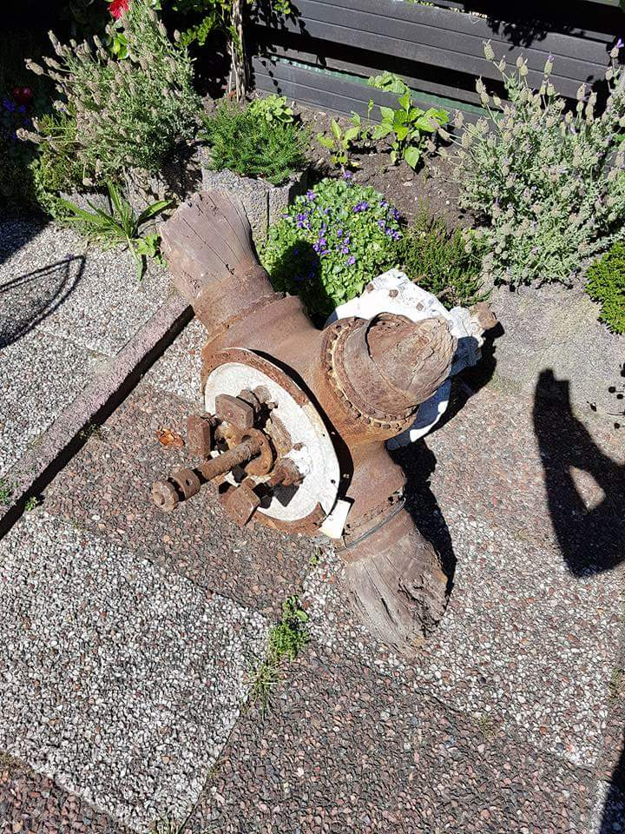
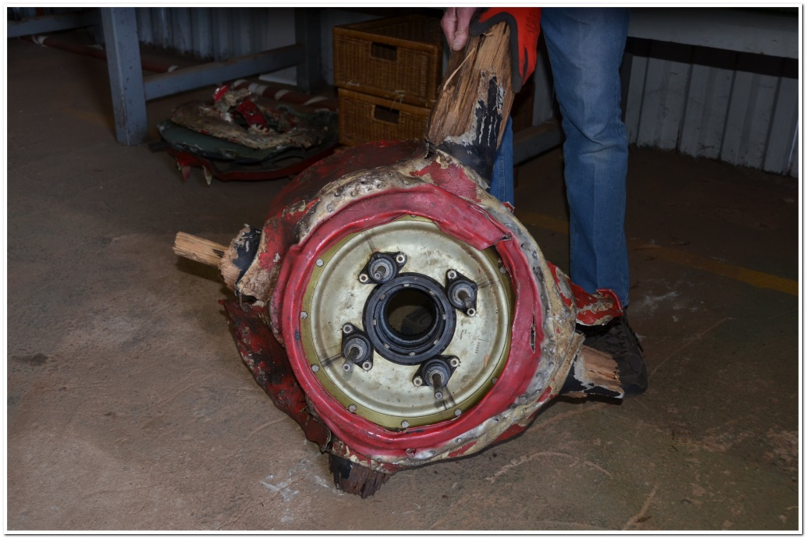
We are not asking you to dig one up in your garden but you never know a dig around the garage can often bring rewards.

Tradesmen
We still require many more volunteers particularly Aircraft technicians, metalsmiths and carpenters.

Language of WWII
Erk’s (The shortening of the cockney rhyming slang for aircraftsmen i.e. ground crew fitters, riggers, armourers etc.) Sad! However in the airforce, hierarchical order of importance.
1) Spitfire 2) ERK's 3) Pilots
Yes, we will need a pilot but we need you ERK’s right now!

Training
Looking for training on the removal and replacement of rivets to aircraft standards? The Spitfire contains many thousands of these little beasties.

Tools
Thanks for all your donations so far however not quite complete. Tools still required:
- Spanners and Sockets - BA and Whitworth
- Bench Vices (All Sizes)
- Machines, Lathes, Grinders

Artworks
We are currently organising an auction of Art connected to the “Spitfire” and require items for auction. Donate an art work and we will sell copies/prints on the stall at air shows we attend. Our media coverage will ensure you publicity.
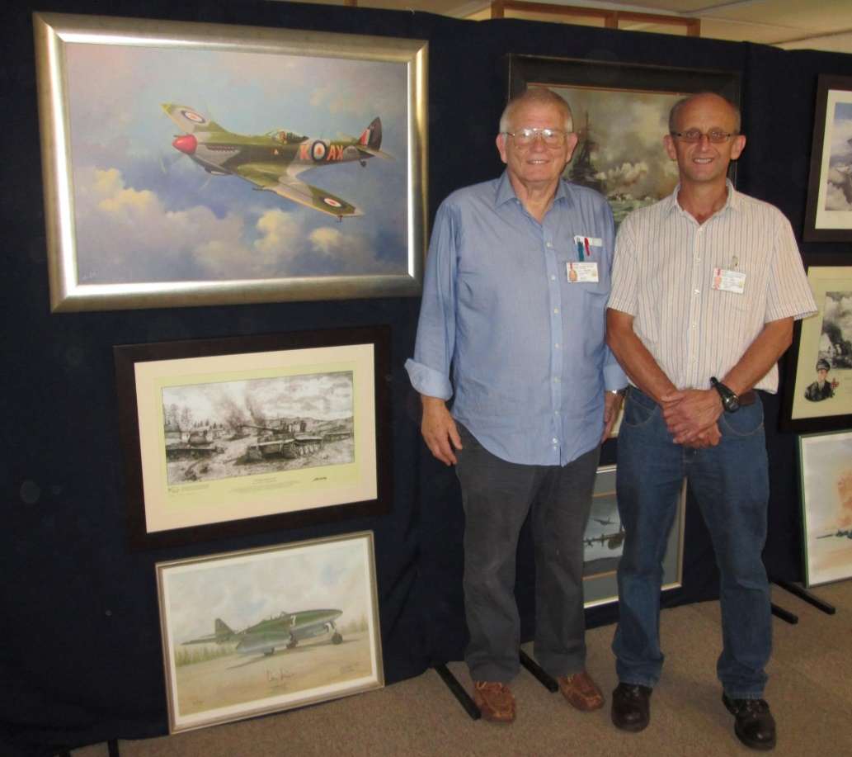
Keith Pratt, October 2017.

