Project Update - March 2017

Sadly we say our goodbyes to Nic Pretorius, member of the Friends of the SAAF Museum, who passed away recently in hospital. Our condolences go to Francois and other members of his family. Whilst not a member of the Spitfire Project, Nic was one of those Friends who would join us whenever needed and contribute to our cause. He will be sorely missed but I'm sure he will continue engineering away in Heaven.
Well, it's March already! Doesn't time fly!
As for the updated progress on the project, I would have to say it has been a good month!
Thanks to Mike and the Saturday crew, the electrical loom has been removed and is currently being assessed. As Mike was part of the installation crew during the initital restoration, he was involved in un-picking his own efforts from 20 years ago (whilst working for Denel). This must have brought back some memories!
Thanks to Clive and Robert (the regular Wednesday Crew) for their efforts in also removing, amongst other items, all the hydraulic piping from inside the fuselage. Their photographic skills come into play when it comes to identifying, labelling and storing all these small items.
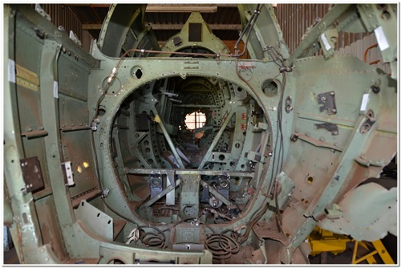 | 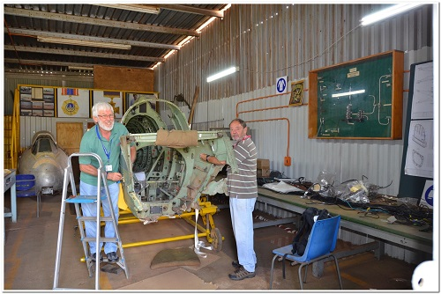
All these items have to be listed with their location and accompanying photographs, etc., which is where we find Horst hard at work refining the database to accept every single screw that is removed from our beloved warbird.
Another angle on this project is the sharp learning curve involved when you have a project which includes nuts, bolts, screws, etc., of such a mixed origin and that vintage. They include BA, Whitworth, BSF, Metric, ANF, ANC and possibly a few others.
The Merlin Engine of our Warbird was inspected. We are now making efforts to get regular access, so that we can commence a similar process to the fuselage in inspecting and recording all components. Check out the video on Spitfire 5518, how graceful she looks, and how gorgeous she sounds with the Merlin!
We must again say thanks to the Modellers and Artists groups of the Friends as they assist us in our endeavours: their sub-projects are nearing completion and evidence of their work will be displayed shortly.
Thanks to WO Henk du Bruin, not only for his immense contribution as liaison officer in the Museum but also his practical assistance and advice.
Preparation for the upcoming airshow goes ahead at full steam as we aim to make it another great and successful event.

Spitfire Simulator - A new Direction
We are currently investigating the costs to build and install a Spitfire Simulator in our workshop. This is a tactic used in most museums in the UK to encourage family groups to visit their premises. It will cost an estimated R25,000, so we are also looking for sponsorship for this amount in the electronics and simulator business sectors. Our simulator will be as close a replica to the real Spitfire as we can make it. Any ideas regarding this will be most welcome.

Fuel Tanks
We are also looking for companies with the skills to test and repair these items, as well as anyone who could offer sponsorship.
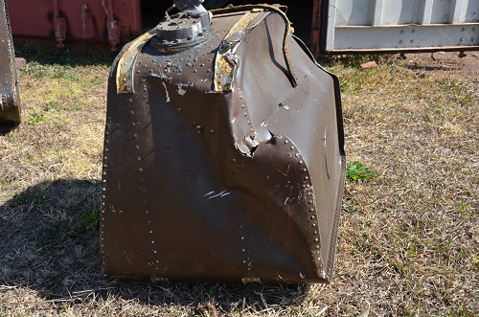 | 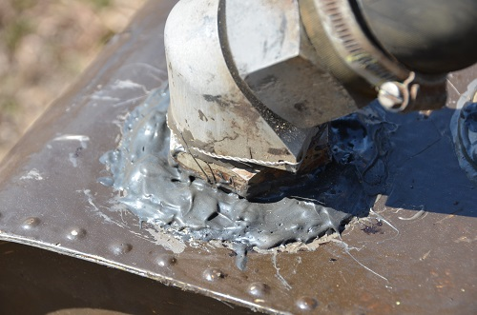

Spitfire Reunion
A special re-union event took place at Swartkop Museum on the 1st of April. A special report on the event will be published soon!

A Special Welcome
Welcome aboard Karen Heydenrych, of Communikay! Our newest member of the steering committee dealing with all matters PR (Public Relations).

A Huge Thank You!
Larry Homan of "Paterson Hughes Engineering" for his exceptional donation of R1,000 towards office computers Thanks so much!

Faith, Hope, and Charity
The story of 3 martyred saints from ancient history. We will provide the Faith and Hope that we can complete this project but we certainly need your Charity with a number of items:
We are always looking for Donationa, Sponsoship, Skills and Memorabilia!
We still need, Computers, Bench Vinces, Imperial Tools, and Workshop Machinery. More on how you can help here!
If there is something in your grage that you don't want, throw it out way, we might need it!

Kind Regards,
K. Pratt
Operations Manager

