Project Update - March 2018
Time passes quickly as the May SAAF Museum Air Show approaches. As in previous years, this causes project progress to slow, but on the positive side there are thousands of visitors, and it stimulates people to become new members. Why not visit the Air Show at Swartkop on Saturday 5th May, and come and talk to us.The highlight of the last two months has undoubtedly been the Pilots Lunch which took place on Saturday 4th November in conjunction with the latest Museum flying day. Great to see these heroes in the flesh and to talk to them of their experiences. Our thanks go to Ian Grace and all those who assisted in organizing the project, including the Friends who are not members of the Spitfire group and the Irene Air Scouts.

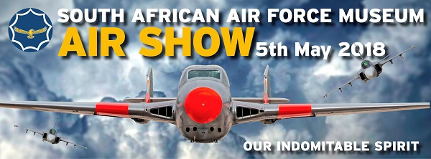

I am currently in the UK resolving personal matters and also visiting RAF establishments to track down technical manuals for our Spitfire. The RAF is celebrating its centenary, of course, with events all over the UK, many involving Spitfires.
Anyone currently holding books, drawings, etc., should contact us. These items may contain one of the crucial items that we still require, or support our library and assist us with future projects.
A further gathering of South African Spitfire Pilots took place on 7th April and was again a great success. Three past chiefs of the South African Air Force were present.
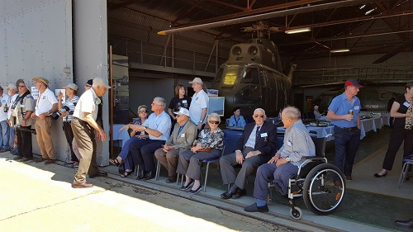 | 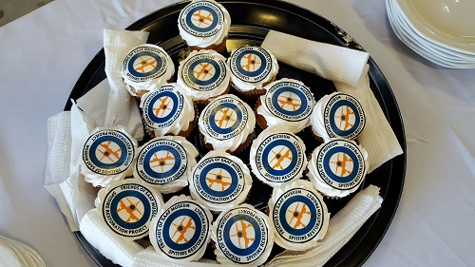

When the SAAF’s Shackleton 1717 was scrapped, four people each bought one of its Griffon engines. One of these was Ian Reeds, and after an enormous amount of hard work, he has got it up to running condition again. This was demonstrated at AFB Swartkop on 7th April, and was probably audible in Durban. We hope to be able to repeat the demonstration at the May Swartkop air show.

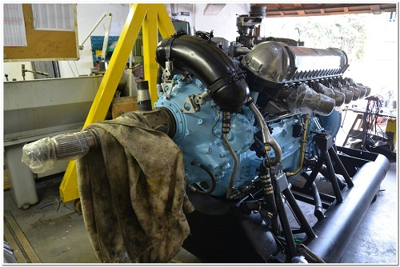
Above: The Griffon engine in the workshop
We hope to have good news soon on erecting the workshop/hangar for the project. Significant funding is required for this. (We have an immediate need for anyone who can help us with Crowdfunding to raise these funds please - see further down.) The hangar will serve as a necessary workshop for our Spitfire as well as for future training and upskilling for the youth.
Vincent has re-stocked the shop for the air show and will have a wide range of items on display and for sale.
Keegan and Karen continue with their work on the Website and our social media channels. If you are a Facebook fundi, please like our page? The logging and inspection of components is also ongoing.

Current Situation: What drives our workforce?
Person 1 (I can't do it...) I have 3 kids, a husband, we’re up backed up on bills and credit cards working 50 plus hours per week, it’s just not realistic!
Person 1 (I can do it...) I have 3 kids, a husband, we’re backed up on bills and credit cards, working 50 plus hours per week. This is something I have to do for my family to get out of our current situation!
The fundamental difference between two people with the same circumstances is that one uses their circumstances as an excuse and the other uses their circumstances as a motivation. Don’t be person 1; let’s use our circumstances to motivate us and to drive ourselves forward to do something new and different.

Recent Contributions

Douglas Kinsey is one of regular donators over recent months. He has further contributed by donating a Spitfire painting depicting the Spitfire flown by his father, which now adorns the wall in the clubhouse committee room. He has also contributed a large collection of hand tools: a great help in stocking our workshop shelves for this and further projects.
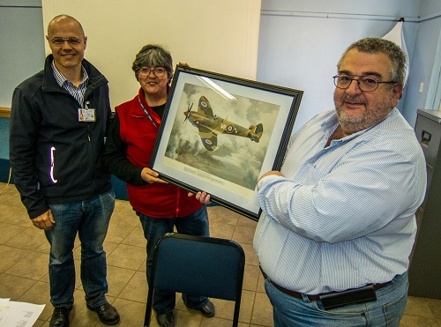
Above: Douglas presenting the painting to Rob Cathro, chairman of the Pretoria branch of the Friends, and Debra Bagshaw, clubhouse manager.

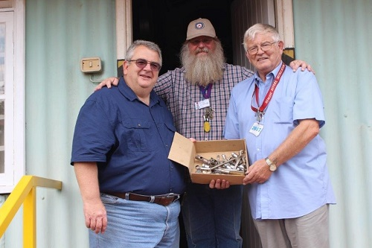
Above: Douglas presenting the tools to Phil Scallan, project CEO, and Keith Pratt, the project operations manager
As explained in our previous Project Update Andre Roux has donated the electronics for the Spitfire Simulator which have now been tested and assembled thanks to Theo Burden and it is all now ready to go.
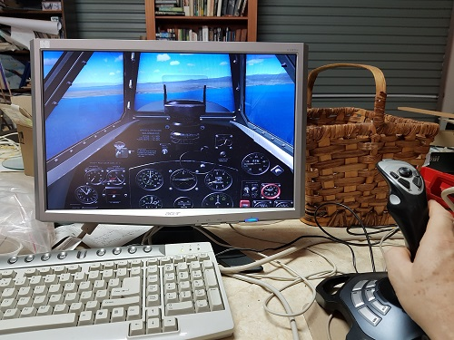
Above: Inside the (simulated) Spitfire cockpit.
Monty van Elling has kindly donated a complete desktop computer, already installed in the workshop office and receiving weekly information as part of our components database uploads. Monty you are a star!
As explained in our previous Project Update Andre Roux has donated the electronics for the Spitfire Simulator which have now been tested and assembled thanks to Theo Burden and it is all now ready to go.
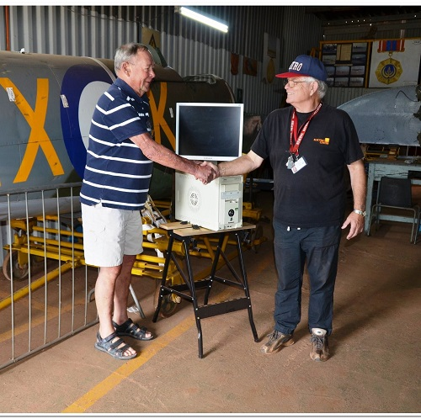
Above: Monty presenting the desktop computer to Keith.
A further donation from Pieter Grobbelaar of “Fly by Wire” is expected soon, which we hope to display at the Airshow.
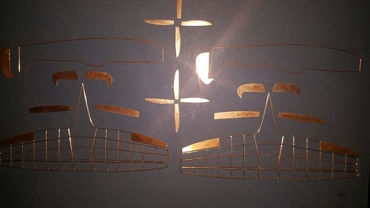
Above: Pieter Grobbelaar's donation from "Fly By Wire"
A further donation from Pieter Grobbelaar of “Fly by Wire” is expected soon, which we hope to display at the Airshow.

Keep the donations coming, please - be they tools, workshop equipment, computers, documents, items we can sell at our shop, your time and energy, your interest, your money!
We continue to seek assistance on the marketing front with specific advice on Crowdfunding: see below.
Until next time!
Keith Pratt
pitfire Restoration Project
Friends of the SAAF Museum
